How many pieces are in a pie?
Are we talking about pizza or the state budget?
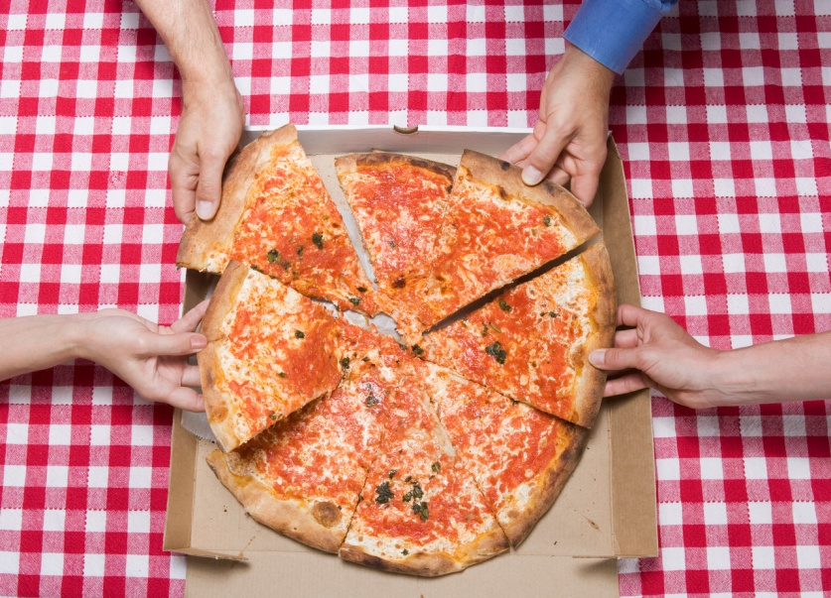
BOTH!
Join WEA-Riverside for Pizza & Politics
WHO: YOU!
WHAT: No agenda, predetermined outcome or “sit and get”
…simply an open space for camaraderie with other politically
minded educators to discuss political issues and policies that
effect education

WHEN: Tuesday, March 19, 2013 @ 4 PM – 6 PM
WHERE: Rocky’s Pizza, 1901 W. Main, Battle Ground, WA
Complimentary pizza and beverages will be served - -
You are responsible for bringing the scintillating conversation!

Grab a friend and RSVP today! Space is limited to the 1st 50 who RSVP!
RSVP to Jan at WEA-Riverside at wea-riverside@washingtonea.org or 256-0880
no later than Wednesday, March 13, 2013!

